Documentation For
“RIVERWATCH”
- PROJECT TITLE
RiverWatch: A Citizen-Driven River Health Monitoring and Complaint Management System

- Installation/Set-up
This is an application which can be easily downloaded from Playstore after publishing the actual product.
It requires -
- SignIn/SignUp
- Registering the details of the user
- Getting access to the features present inside it.
- Project Structure
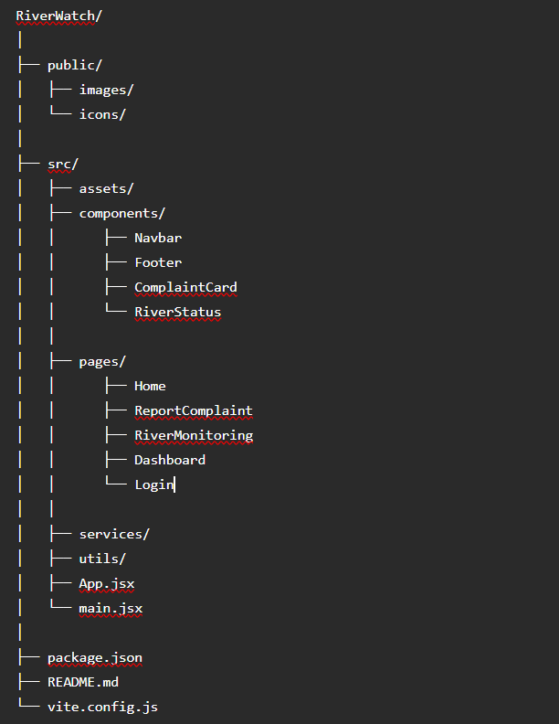

- System WorkFlow
• User logs into RiverWatch.
• Selects a river/location.
• Uploads complaint with description and image.
• Backend validates and stores the complaint.
• Database saves complaint details.
• Admin reviews the complaint.
• Complaint status is updated.
• Users can monitor river conditions in real time.

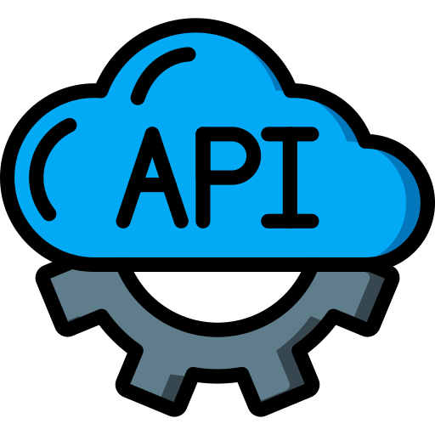

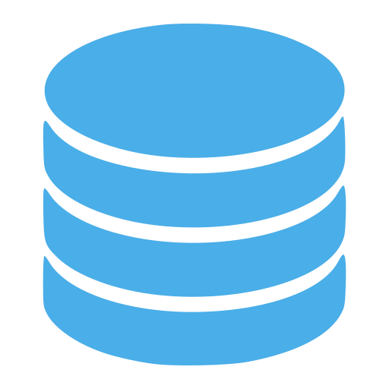
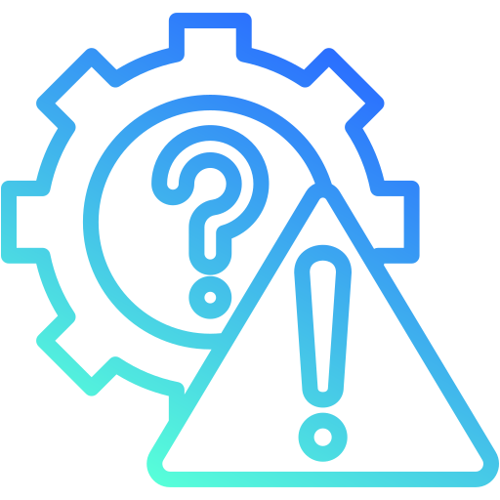


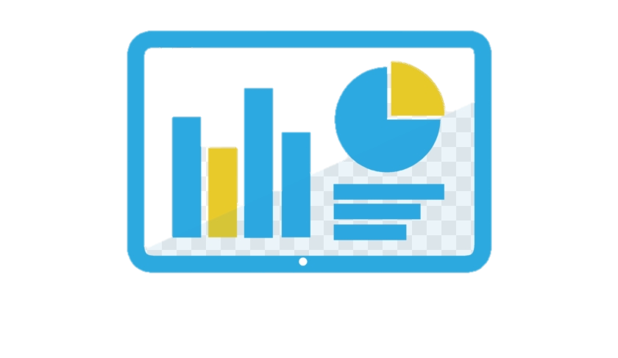

- Technology Stack
Frontend Technology –
Flutter, HTML+CSS, Google Map API
Backend Technology –
Python, Django
Database Technology –
MongoDB, SQL
Security and Deployment Technology –
Amazon AWS, Cloudinary
Analytics and Monitoring Technology –
Matplotlib, Numpy, Pandas libraries
- API Details
Authentication
POST
/api/auth/register
Registers a new user.

POST
/api/auth/login
Logs in an existing user.

Complaints
GET
/api/complaints
Returns all complaints.

POST
/api/complaints
Creates a new complaint.
Request Body
{
"title": "Plastic Waste",
"description": "Large amount of waste near river bank",
"location": "Raipur",
"image": "file"
}

GET
/api/complaints/:id
Returns a specific complaint.

PUT
/api/complaints/:id
Updates complaint status.

DELETE
/api/complaints/:id
Deletes a complaint.
River Monitoring
GET
/api/rivers
Returns river condition information.
- Deployment Details
Frontend
Platform:
- Vercel
Deployment Steps
npm run build
Deploy the generated build using Vercel.

Backend
Platform:
- Render
- Railway
Overall Deployment
Github

- Technical Implementation Details

Complaint Module
- Accepts complaint details.
- Supports image upload.
- Stores geolocation.
- Generates complaint ID.

Authentication Module
- Secure login using JWT.
- Password hashing with bcrypt.
- Session management.
River Monitoring Module
- Displays pollution status.
- Shows latest river updates.
- Maintains historical records.
Admin Dashboard
- Reviews complaints.
- Updates complaint status.
- Monitors river health.
- Generates reports.
Security Features
- JWT Authentication
- Password Hashing
- Input Validation
- File Upload Validation
- Protected Routes
- Known Limitations
- River health data currently relies on user reports rather than live sensor feeds.
- No offline complaint submission.
- Limited image verification capabilities.
- Mobile application is under development.
- Real-time notifications are not available in the current version.
- GIS-based analytics and predictive monitoring are planned for future releases.

- Future Enhancements
- AI-powered pollution detection
- IoT-based water quality monitoring
- Real-time alerts
- GIS heatmaps
- Mobile application
- Government authority portal
- Analytics dashboard
- Multi-language support
- Volunteer management system

